Write-N-Cite 4
Install on home computers from RefWorks (NB: it won’t run on Mac OSX 10.5 or below, only 10.6 and above). 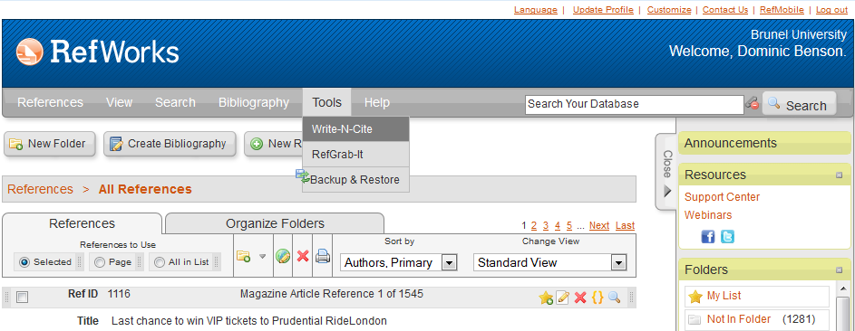
Unless you have a 64-bit version of MS Office, go with the 32-bit version (see image below, second red ring).
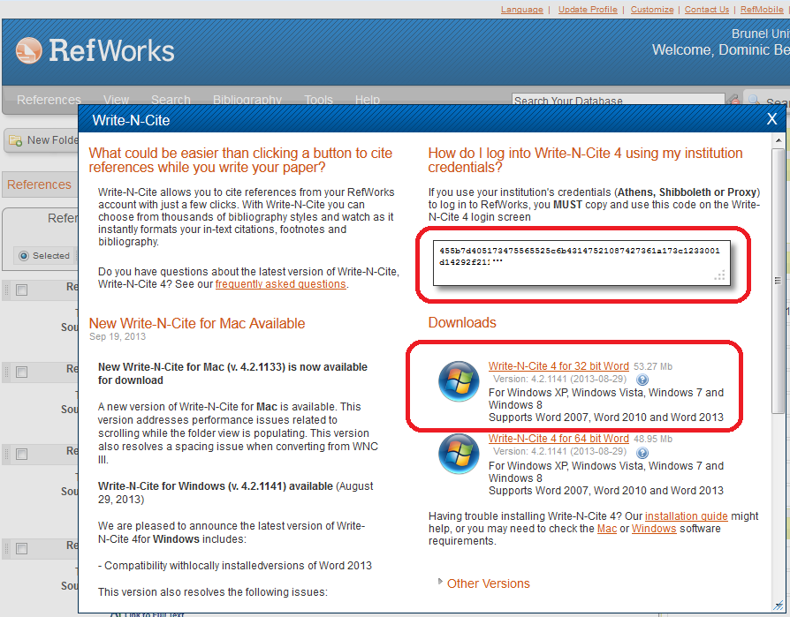
Install WNC, then open Word and look for the RefWorks add-in tab and click on Log In – enter either the Group Code RWBrunelU and your RefWorks credentials or, if you use Shibboleth, you can copy and paste in a long one-time code from RefWorks (see image above, first red ring)
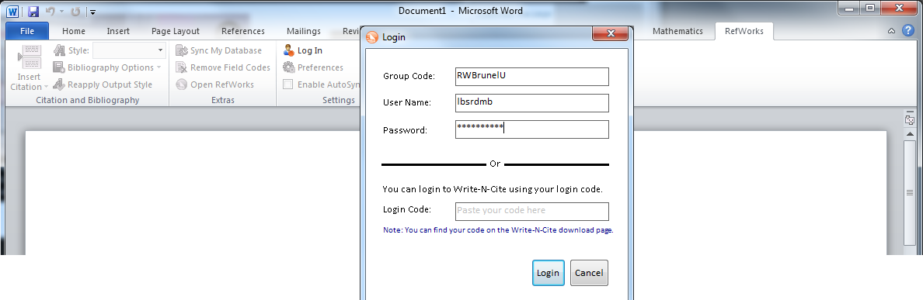
If you used WNCIII before, your document may need to be converted to update it to the WNC4 format
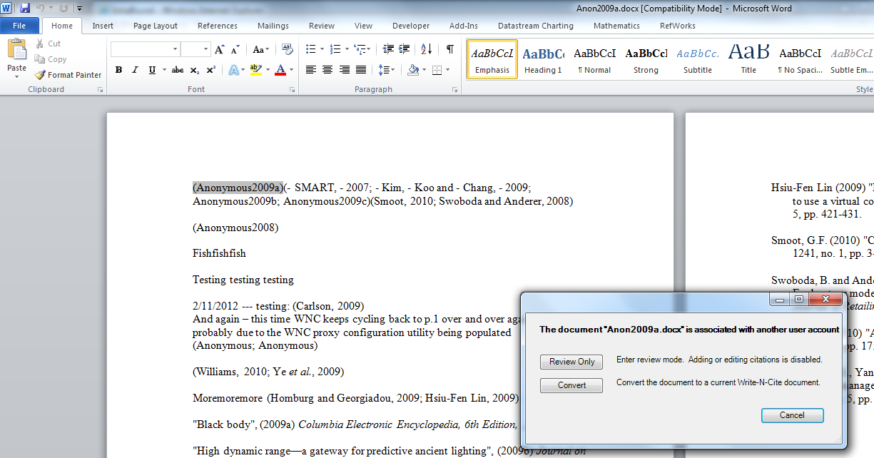
Now you can insert citations on the fly and…
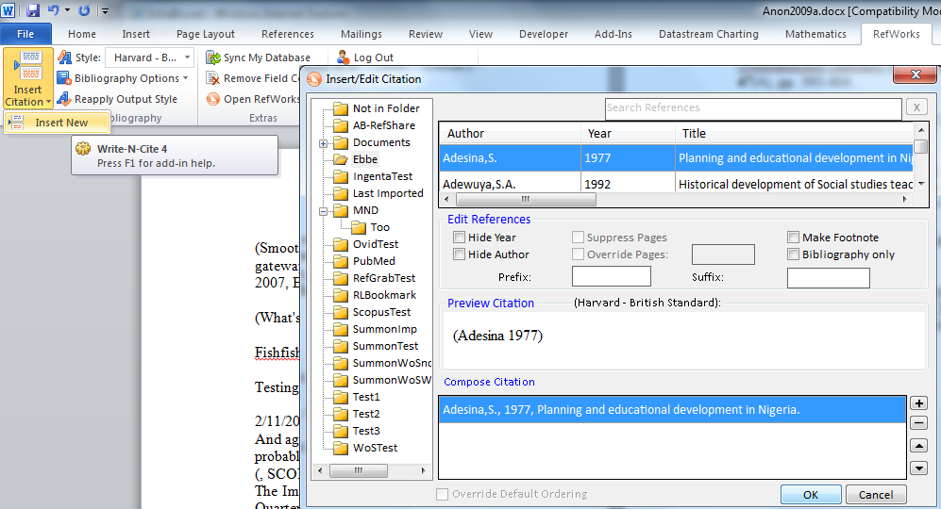
format your bibliography on the fly too. Don’t try to edit your document in different versions of WNC! Stick with one or the other.
